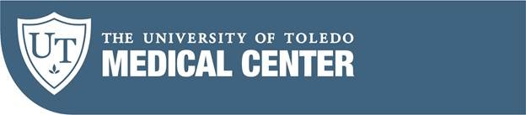 | Quality Assessment, Performance Improvement, and Patient Safety Plan  FY 2020
- Introduction
  - Purpose
The purpose of the Quality Assessment, Performance Improvement (QAPI) and Patient Safety Plan is to support the University of Toledo Medical Center (UTMC) mission and strategic vision by outlining priorities, objectives and overall improvement strategies.

Mission

The mission of The University of Toledo Medical Center is to improve the human condition by providing patient-centered, university-quality care.

Strategic Vision

Transition UTMC to a high performing hospital focused on Primary Care, Behavior Health, Orthopedics and Consultative Services.

  - Situation
The landscape surrounding UTMC is dynamic owing to many factors. At the same time, CMS (the Centers for Medicare and Medicaid Services) has placed greater emphasis on measurement of value-based care: Hospital Compare Quality Star Rating system, the Value-Based Purchasing (VBP) Program, the Readmissions Reduction Program (RRP), and the Hospital Acquired Condition (HAC) Program. UTMC has adapted its Quality and Safety plan to this situation.

  - University of Toledo Goal for UTMC
Grow the reputation and visibility of health care in Toledo provided by UT physicians, health-care providers, residents and students.

  - UTMC Strategic (multi-year) Quality Objectives
In order to support the overall mission, strategic vision, and goals for UTMC we have outlined the following objectives.
    - Achieve Hospital Compare Overall Quality Rating of 3-Stars by December FY2020
    - Eliminate UTMC’s Hospital-acquired condition (HAC) reduction program penalty and neutralize Value-Based Purchasing related penalties by CMS FY2021.
    - Improve clinical documentation
    - Improve health quality information management
    - Maintain accreditation and certification readiness

  - Fiscal Year 2020 QAPI and Patient Safety Plan Priority Objectives
We have outlined our FY 2020 objectives to support the UTMC strategic objectives. We have organized them according to the Institute of Medicine (IOM) six dimensions of quality: safe, timely, effective, efficient, equitable, and patient-centered. The most important objective is safety. We will employ CMS (the Centers for Medicare and Medicaid Services), Vizient, the Hospital Consumer Assessment of Healthcare Providers and Systems (HCAHPS), and UTMC data sources to measure our progress toward meeting objectives.
      - Safety
        - Patient safety indicators (PSIs)
          - Decrease pressure ulcers (PSI03) to below Vizient median
          - Decrease postoperative respiratory failure (PSI11) to below Vizient median
          - Decrease perioperative pulmonary embolism and deep vein thrombosis rate (PSI12) to below Vizient median
          - Maintain postoperative sepsis rate (PSI13) to below Vizient median
        - Healthcare-associated infections
          - Decrease the surgical site infection rate below the Center for Disease Control-National Healthcare Safety Network (CDC-NHSN) standardized infection rate (SIR) threshold
          - Decrease the catheter-related blood stream infection rate below the CDC-NHSN SIR threshold
          - Decrease the catheter-associated urinary tract infection rate below the CDC-NHSN SIR threshold
          - Decrease the Clostridium difficile infection rate below the CDC-NHSN SIR threshold
        - Improve hand-hygiene to achieve an average above 90%
        - Improve Operating Room (OR) safety culture to achieve self-reported OR safety of at least 80% in all domains
        - Decrease service line specific mortality rates below Vizient index
        - Decrease UTMC overall mortality rate below Vizient Index
        - Improve overall perception of safety by 10%. Measured via AHRQ Culture of Safety Survey question (Our procedures and systems are good at preventing errors form happening) from 60% to 66%.
      - Timeliness
        - Maintain Emergency Department (ED) to admission time below Vizient median

      - Effectiveness
        - Decrease UTMC overall 30-day readmission rate by 20% (Vizient) from FY2019 10.8 to 8.6.

      - Efficiency
        - Improve OR on-time start percentage to above 80% for UTMC surgical services
        - Improve overall UTMC clinical documentation capture of Medicare Severity Diagnosis Related Groups (MS-DRGs) complication or comorbidity (CC) or a major complication or comorbidity (MCC) (i.e., MS-DRG CC/MCC) by 10% from FY2016 CMI (Vizient) of 1.66, or 0.166.

      - Equitable
        - Decrease median time from ED arrival to departure for all races and low socio-economic statuses

      - Patient-centeredness
        - Achieve 32nd HCAHPS percentile (for rating the hospital overall)
        - Achieve Vizient ranking of 25 for patient-centeredness domain

7. Maintain accreditation and certification readiness (Table 1).

- Structure and Leadership
  - The UTMC executive team is responsible for developing the Quality Assessment, Performance Improvement and Patient Safety Plan. These leaders set priorities, provides leader emphasis, and allocates resources to support the plan.
  - Execution of the plan carried out by committees, working groups, departments, and services (Figure 1). These committees, working groups, departments, and services operationalize the plan, defining, refining, implementing, and monitoring. These bodies are comprised of physicians and appropriate hospital staff.
  - Each clinical department will develop performance improvement initiatives that align with the UTMC quality and safety plan.
  - The CMO oversees the plan as the Chair of the Quality and Patient Safety Council. This oversight ensures quality and safety activity alignment within the organization and allows for collaboration while avoiding redundancy. The Quality and Patient Safety Council reports to the Medical Staff Executive Committee, which in turn reports to the Clinical Affairs Committee of the Board of Trustees (Figure 2).

- Quality Assessment and Performance Improvement Process
  - Setting Priorities
Quality priorities align with UTMC objectives and meet regulatory requirements. The CEO outlines, priorities, but obtains input from other hospital leaders and service chiefs. Other issues (e.g., external benchmark projects, analysis of patient safety event reports, sentinel event analysis, or standard of care findings) may also receive priority. UTMC uses decision matrices along with other modalities to aid in developing priorities (Table 2).

b. Model for Quality Assessment and Performance Improvement
UTMC will transition during this year to employing the widely used Institute for Healthcare Improvement (IHI) model. This model is comprised of the following questions/steps:
    - What is the aim (what is trying to be accomplished)?
    - What will be measured (how will we know a change is an improvement)?
    - What change/intervention will be made?
    - Following these three questions, we execute the PDSA cycle (Plan-Do-Study-Act) (Figure 3).
    - Key resources will include IHI’s QI Essentials Toolkit using the tools and templates needed to launch and manage a successful improvement project. These tools help PI teams follow a standardized approach to accomplish their goals. The Performance Improvement methods are designed to assist with implementing appropriate action plans for variances, selecting quality tools, and launching PI projects/initiatives. Example of tools (Figure 4 & 5).
    - Tools:

- PDSA / worksheet  - Driver Diagram  - Flowcharts  - Cause and Effect Diagrams  - Run, Pareto, Control charts  - Histogram  - Scatter Diagram | - Lean/Six Sigma, Value stream mapping  - Root Cause Analysis (RCA)  - Case Investigation  - Evidence Based/Best Practice review  - Failure Mode and Effects Analysis (FMEA)  - Surveys  - Audits

    - The Quality and Patient Safety Plan is flexible in order to accommodate change.

c. Developing Measure Specifications
Committees and working groups outline quality measures and metrics. UTMC relies on Vizient, CMS, and organic resources for actionable data. Committees and working groups develop written measurement specifications along with data abstraction tools with assistance from Quality Management personnel.

d. Reporting and Implementation
Committees, working groups, departments, and services will report findings to the Quality Management Department. The Quality Management Department is responsible for disseminating important information throughout the organization, in such formats as the Performance Improvement Quarterly report and/or other acceptable formats. Annually or more frequently as necessary, findings from committees, working groups, departments and services will be presented at the Quality and Patient Safety Council, with minutes from the council presented to the Medical Executive Committee. UTMC performance improvement activities may also be shared in the following modes:
    - Departmental in-services on special quality performance improvement topics
    - Presentations to students, residents, staff and faculty
    - Reports of clinical data distributed to the Clinical Affairs Committee of the Board of Trustees, Executive Committee of the Medical Staff, members of management and leadership teams
    - Display of duality data on individual hospital units

IV. Medical Staff and Clinical Department and Services Quality and Safety Responsibilities
- Medical Staff Committees
All UTMC committees report their plans and activities to the Quality and Patient Safety Council at least annually. As medical staff committees, several key committees must also submit their activities (in the form of minutes) to the Medical Executive Committee. These committees and their activities include:

    - Blood and Laboratory Utilization Committee (BUC): The purpose of the committee is to ensure the safe, effective, and efficient use of blood products and appropriate use of the laboratory resources. The committee annually reports their plan and findings to the Quality & Patient Safety Council.

    - Cancer Committee: The purpose of the committee is to ensure quality care in patients with cancer. Cancer Conference presentations occur monthly, which includes all major cancer sites treated at UTMC. The Cancer Committee plans and conducts a minimum of two outcome studies annually. The committee annually reports their plan and findings to the Quality & Patient Safety Council.

    - Infection Control Committee: The purpose of the committee is to ensure safe care by instituting and overseeing evidence-based infection control practices. The committee also ensures integration and oversight of the antimicrobial stewardship program. The committee meets no less than quarterly to review and evaluate the hospital-wide infection control activities. The committee annually reports their plan and findings to the Quality & Patient Safety Council.

    - Health Information Management Committee: The purpose of the committee is to ensure the timely completion and accuracy of medical documentation (e.g., history and physical). The committee monitors regulatory requirements for completion of required documentation. The committee annually reports their plan and findings to the Quality & Patient Safety Council.

    - Operating Room (OR) Services Committee: The purpose of the committee is to ensure the delivery of quality surgical care. The committee reviews all adverse events and mortalities that occur in the OR. The committee annually reports their plan and findings to the Quality & Patient Safety Council.

    - Pharmacy and Therapeutics Committee: The purpose of the committee is to oversee all aspects of quality related to the selection, ordering, transcribing, preparing, dispensing, administering, and monitoring of medications throughout UTMC. In addition, they maintain and make recommendations to the drug formulary. The committee works closely with nursing, Infection Control, and other medical staff departments in developing policies and monitoring. Pharmacy is responsible for tracking and monitoring medication errors and adverse events and reporting findings to the Quality & Patient Safety Committee. The committee annually reports their plan and findings to the Quality & Patient Safety Council.

    - Trauma Committee: The purpose of the committee is to provide quality oversight for the Trauma program. The committee annually reports their plan and findings to the Quality and Patient Safety Council.

- Clinical Departments and Services
    - Each clinical department and service is responsible for establishing specific quality improvement indicators, which align with the hospital-wide plan. Clinical departments and services annually report their plans and findings to the Quality and Patient Safety Council.

- Safety
  - Safety is the most important aspect of quality care. UTMC integrates the patient safety with all quality assessment and performance improvement activities. It encompasses risk assessment and avoidance tactics such as conducting a “Failure Mode Effect Analysis” (FMEA). FMEA is a proactive risk assessment, which examines a process in detail including sequencing of events, assessing actual and potential risk, failure, or points of vulnerability, and prioritizes areas for improvement based on the potential impact on patient care.

  - The Quality Management department proactively institutes action plans based on findings from the “Sentinel Event Alert” provided by the Joint Commission.

  - All patient safety events in the safety program track and trend or initiate activities that address process, system, protocol, or equipment events. This includes near miss occurrences and unsafe conditions, as well as findings from adverse events. As the entire organization reports patient safety events, this component integrates all departments into the safety program.

  - The Quality Management department facilitates execution of action plans derived from Root Cause Analysis activities, including those from Sentinel Events.

- Oversight and Information Sharing
  - Committees, working groups, departments and services report quality assessment and performance improvement information to the Quality and Patient Safety Council. The Quality and Patient Safety Council submits minutes to the Medical Staff Executive Committee, which in turn reports to the Clinical Affairs Committee of the Board of Trustees. Additionally, the Clinical Affair Committee approves the annual Quality Assessment, Performance Improvement and Patient Safety Plan and monitors completion of the plan. The various duties of these oversight committees are further defined below:

    - The Board of Trustees of the University of Toledo: establishes, maintains, supports, and exercises oversight of the quality monitoring and performance improvement function of UTMC. The Board of Trustees fulfills its responsibilities related to the quality assessment, performance improvement, and safety functions through its Clinical Affairs Committee.

    - The Clinical Affairs Committee of the Board of Trustees: reviews and provides feedback related to quality reports submitted to the committee and the Board of Trustees. The Clinical Affairs Committee approves the annual plan and annual reappraisal. They are also responsible for making recommendations to enhance the Quality Assessment, Performance Improvement and Patient Safety Plan.

    - The Executive Committee of the Medical Staff: provides oversight for reporting quality initiatives from the medical staff committees and hospital initiatives.

- Resources
  - The Quality Management Department supports and facilitates ongoing organizational quality assessment, performance improvement, and patient safety activities. The Quality Management Department assists physicians and hospital staff with developing and executing quality improvement projects.
  - The duties of the Quality Management Department include:
    - Promoting patient safety through evidence-based clinical programs and initiatives
    - Ensuring accreditation and certification readiness (e.g., Joint Commission)
    - Management of quality databases (e.g., Vizient, CDC databases, National Database of Nursing Quality Indicators (NDNQI). American College of Cardiology (ACC) national database, and Patient Safety Net event reporting.)
    - Collaboration with all departments and services to execute the quality and patient safety plan (e.g., assisting with performance improvement projects) and achieve hospital objectives
    - Collaboration with Medical Staff Office/Central Verification Office (CVO) for physician assessments
    - Quality improvement training and education
    - Preparation of all salient quality and safety plans and reports
    - Collaboration with health information management to aid in accurate documentation
    - Dissemination of patient safety event reports to departments, Quality and Patient Safety Council, and other key groups in the organization
    - Patient safety event and sentinel event report tracking and analysis
    - Coordinating and leading root cause analyses for sentinel events and other occurrences requiring intense analysis
    - Coordinating and ensuring completion of action plans related to sentinel events or failure mode effect analysis (FMEA) projects
    - Organizing performance improvement projects for issues found in patient safety event reports
    - Oversee submission of data to CMS, third party payers, and other collaboration efforts.
    - Support provider data aggregation, analysis, and validation.
    - Provide clinical case reviews for adverse events, triggered reviews and support reviews for M&M and Peer Review processes.

- Summary

The Quality Assessment, Performance Improvement, and Patient Safety Plan provides the objectives and framework for UTMC to implement quality assessment, performance improvement, and safety activities. These activities improve patient outcomes, patient experience, and patient safety in a comprehensive, methodical, and systematic manner and compliment the Hospital Plan for the Provision of Collaborative Patient Care Services.

IMMUNITY/CONFIDENTIALITY CLAUSES

The Quality and Patient Safety Council is a UTMC quality assurance committee as referenced in the Ohio Revised Code. Those sections of the Ohio Revised Code pertaining to immunity and confidentiality apply to the Quality and Patient Safety Council.

Ohio Revised Code §2305.24 (eff. 9/29/2009)
“Any information, data, reports, or records made available to a quality assurance committee or utilization committee of a hospital or long-term care facility or of any not-for-profit health care corporation that is a member of the hospital or long-term care facility or of which the hospital or long-term care facility is a member are confidential and shall be used by the committee and the committee members only in the exercise of the proper functions of the committee.

No physician, institution, hospital, or long-term care facility furnishing information, data, reports, or records to a committee with respect to any patient examined or treated by the physician or confined in the institution, hospital, or long-term care facility shall, by reason of the furnishing, be deemed liable in damages to any person, or be held to answer for betrayal of a professional confidence within the meaning and intent of section 4731.22 of the Revised Code.”

Original Date: 9/87
Revised:
Utilization Management Plan 4/90
Quality Assessment Plan 6/90
Quality Assessment and Improvement Plan 7/92
Patient Care and Service Improvement Plan 1/93
Quality Improvement Plan 1/94
Quality Improvement Plan 1/95
Quality Improvement Plan 1/96
Quality Improvement Plan 1/97
Quality Improvement Plan 1/98
Quality Improvement Plan 1/99
Performance Improvement Plan 4/99
Performance Improvement Plan 6/99
Performance Improvement Plan 9/00
Performance Improvement Plan 3/02
Performance Improvement Plan 5/03
Performance Improvement Plan 12/04
Performance Improvement Plan 6/06
Performance Improvement Plan 11/07
Quality and Patient Safety Plan 12/08
Quality and Patient Safety Plan 2/2010
Quality and Patient Safety Plan 2/2012
Quality and Patient Safety Plan 12/2012
Quality Assessment, Performance Improvement and Patient Safety Plan, 11/2013
Quality Assessment, Performance Improvement and Patient Safety Plan, 1/2015
Quality Assessment, Performance Improvement and Patient Safety Plan, 7/2015
Quality Assessment, Performance Improvement and Patient Safety Plan, 8/2016
Quality Assessment, Performance Improvement and Patient Safety Plan, 8/2017
Quality Assessment, Performance Improvement and Patient Safety Plan, 8/2018
Quality Assessment, Performance Improvement and Patient Safety Plan, 8/2019

________________________________________
Dan Barbee
Chief Executive Officer

________________________________________
Michael Ellis, M.D.
Chief Medical Officer

________________________________________
Samer Khouri MD.
Chief of Staff

Table 1 Regulatory Agencies
Continuous Readiness

Figure 1
Quality & Patient Safety Initiative
Care and Safety Oversight
ACCESS
Care is Appropriate
Pt. Satisfaction/Complaints
Behavioral Mgmt.
Readmissions/Infections
Resuscitation
Quality & Patient Safety Council
Care is Safe
Care is Effective
Care is Efficient
Readmission
Resource Utilization
Medical Staff Executive Committee
Pharmacy & Therapeutics

Procedural Case Review
Operating Room
Health Information Management
Endoscopy
Infection Control
Cancer
Lab/Blood Utilization Review
MEDICAL STAFF QUALITY
Anticoagulation
CT Radiology
Decubitus
Pain/Opioid
Medication/Drug Reactions
Moderate/Deep Sedation
Falls
Restraints
National Patient Safety Goals
PATIENT CARE SAFETY
Emergency Department
FISCALLY RESPONSIBLE
Operating Room Services

Bed Flow
Ambulatory Clinics limics

Care is Equitable and Patient Centered
Care is Timely

GUIDELINES/OUTLIERS

Core Measures

Infection
Antibiotic Stewardship
Trauma
Renal Transplant

Figure 2
Clinical Affairs Committee of the Board of Trustees
Nursing
COMMITTEE STRUCTURE
October 2019
Medical Executive Committee

Quality & Patient Safety Council

OR Service Committee
Sedation
Opioid/Pain
Lab/Blood Utilization Review Committee
Health Information
Management
Service Excellence
Procedural Case Review/Pathology
Resource Utilization
Committee
Radiology
Fall
Dialysis
Pharmacy & Therapeutics Committee
Cardiac Cath Laboratory
Stroke
Heart Failure
Behavioral Health
Cancer Committee
Code Committee/Rapid Response
Trauma Committee
Restraint
Skin Care
Medication Management
Endoscopy
Transplant
Infection Control

Table 2

PRIORITIZATION MATRIX –FY 2019

Quality and Patient Safety Goals

Improve Patient Safety & Quality
Opportunity | High Risk | High Volume | Problem Prone | Important to Mission | Customer Satisfaction | Staff Satisfaction | Physician Satisfaction | Clinical Outcome | Safety | Regulatory Requirement

Hospital Acquired Conditions
Patient Safety Events
Pain Management – Safe opioid use
Improve Resource Utilization
Opportunity | High Risk | High Volume | Problem Prone | Important to Mission | Customer Satisfaction | Staff Satisfaction | Physician Satisfaction | Clinical Outcome | Safety | Regulatory Requirement
Reduce Readmission

Improve Satisfaction
Opportunity | High Risk | High Volume | Problem Prone | Important to Mission | Customer Satisfaction | Staff Satisfaction | Physician Satisfaction | Clinical Outcome | Safety | Regulatory Requirement

Patient Satisfaction

Perception of Safety

Complaint Management

Reduce Infection Rates
Opportunity | High Risk | High Volume | Problem Prone | Important to Mission | Customer Satisfaction | Staff Satisfaction | Physician Satisfaction | Clinical Outcome | Safety | Regulatory Requirement

Clostridium Difficile

Blood Stream Infections

Hand Hygiene

Surgical Site Infections

UTI

Monitor External Regulatory Compliance Indicators
Opportunity | High Risk | High Volume |  | Problem Prone |  | Important to Mission |  | Customer Satisfaction |  | Staff Satisfaction |  | Physician Satisfaction |  | Clinical Outcome |  | Safety |  | Regulatory Requirement

Resuscitation
Sedation/Analgesia
Pain
Resource Utilization
CORE Measures
Adverse Drug Reaction
Organ Conversion
Restraints
Opportunity | High Risk | High Volume |  | Problem Prone |  | Important to Mission |  | Customer Satisfaction |  | Staff Satisfaction |  | Physician Satisfaction |  | Clinical Outcome |  | Safety |  | Regulatory Requirement
Lab/Blood Utilization
Operative/Invasive procedures.
Seclusion
Behavioral Management
Mortality/Autopsy
Hazard Management
Operative Diagnosis Concurrence

NPSG

CT Radiology indicators

Suicide Risk
Falls
Medication Errors
Patient Throughput
Antimicrobial Stewardship
Contracted Services
ECT
Detox

Figure 3

Plan-Do-Study-Act
Quality & Patient Safety Cycle

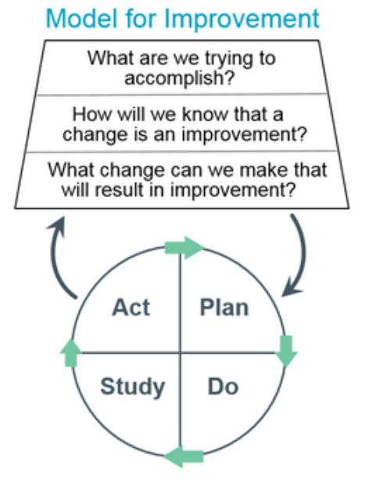

Figure 4
QUALITY PERFORMANCE IMPROVEMENT QUARTERLY REPORT

THE PDSA QUALITY CYCLE

Team/Disciplines: ______________________________________________________________

Plan (Aim): (Identify your problem using priorities from the Quality and Patient Safety Annual Plan or issues identified as affecting important outcomes of care, treatment or service.)
- Describe the objective:
- List questions and make predictions:
- Specify how to carry out the cycle:
  - Who
  - What
  - Where
  - When
- How will cycle results be measured:

Do (Intervention): (Carry out the plan, start with pilot or small scale. Observe impact, document problems, collect data and gather informal feedback. Share real-time results if possible to make just in time changes when able.

Study (Measures): (Study results—how did implementation go? Were results achieved? Show data via tables and graphs. Compare results to predictions. What did you learn? Summarize quantitative and qualitative analysis. Quantitative: Which way is the experience moving - up down or static over time? Is this desirable or undesirable? Is the process in control, or does it have a lot of variation? How does the experience compare to the Goal or Benchmark. Qualitative: Why is this happening? Consider all reasons. What are the contributing factors? What does this mean?)

Act (Analyses): (What did you conclude from this cycle review? Refine the change based on what was learned from the do/study. Did the implementation work or not? If it did not work, what can you do differently in next cycle to address this? If it did work, can you spread across entire practice? Should this continue to be measured? Should another indicator be introduced? )

Contact Person Completing Form: _____________________________________Dept.______________________

Return completed form to Quality and Patient Safety, Room 2240, Dowling Hall.

These documents, records, or information contained herein is a confidential professional peer review, quality assurance or incident and risk management reporting documents of UTMC. It is protected from disclosure pursuant to Ohio law and Ohio Revised Code Sections 2305.24 through 2305.253. Unauthorized disclosure or duplication is absolutely prohibited.

Figure 5 Project Planning Form Example
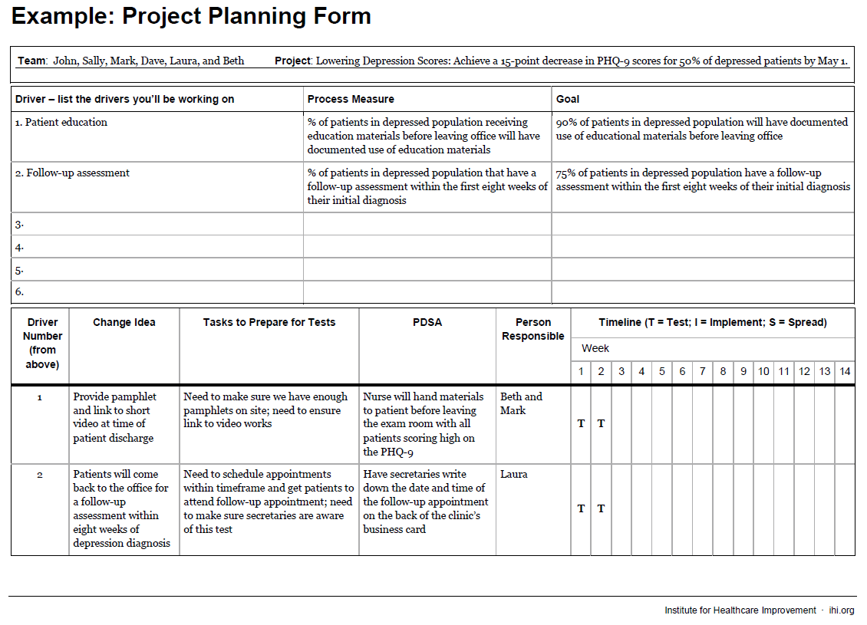
Figure 5a Project Planning Form Example

